NAME:ROSHINI B T
REG NO:192524064
CO4-AT3
QUESTION
Q33. Kruskal vs Boruvka Algorithm (MST Comparison): Given a graph, construct MST using Kruskal and Boruvka algorithms. Compare edge selection process. Analyze efficiency for different graph types. Evaluate computational complexity. Discuss scalability. Generate insights on MST algorithms.
AIM
To implement and compare Kruskal’s and Borůvka’s algorithms for constructing a Minimum Spanning Tree (MST) of a weighted undirected graph, and to analyze their edge-selection strategies, computational complexity, efficiency, and scalability.
OBJECTIVES
- To construct an MST using Kruskal’s algorithm.
- To construct an MST using Borůvka’s algorithm.
- To compare how the two algorithms select edges.
- To calculate and compare the total MST cost.
- To study the time and space complexity of both algorithms.
- To understand the suitability of the algorithms for different graph sizes and types.
THEORY
A Minimum Spanning Tree of a connected, weighted, undirected graph is a spanning tree that connects all vertices without forming a cycle and has the minimum possible total edge weight.
Kruskal’s Algorithm
Kruskal’s algorithm follows a globally sorted edge-selection strategy. All graph edges are considered in non-decreasing order of weight. An edge is added to the MST only when it joins two different components. A Disjoint Set Union (DSU) structure is used to detect cycles.
- Sort all edges in increasing order of weight.
- Initially, every vertex is treated as a separate component.
- Select the lightest edge that does not form a cycle.
- Merge the two components using union operation.
- Continue until V − 1 edges are selected.
Borůvka’s Algorithm
Borůvka’s algorithm works component-wise. Initially, every vertex is a separate component. For every component, the cheapest outgoing edge is identified. All safe cheapest edges are then added to the MST, reducing the number of components. The process is repeated until only one component remains.
- Start with each vertex as an individual component.
- Find the cheapest outgoing edge for every component.
- Add the selected safe edges to the MST.
- Merge the connected components.
- Repeat until the graph becomes one component.
ALGORITHM / PSEUDOCODE
Kruskal’s Algorithm – Pseudocode
KRUSKAL(G)
1. Sort all edges of G in non-decreasing order of weight.
2. Make each vertex a separate set.
3. MST = empty set.
4. For each edge (u, v) in sorted order:
a. If FIND(u) != FIND(v):
Add (u, v) to MST.
UNION(u, v).
5. Stop when MST contains V - 1 edges.
6. Return MST and its total weight.
Borůvka’s Algorithm – Pseudocode
BORUVKA(G)
1. Make every vertex a separate component.
2. MST = empty set.
3. While more than one component exists:
a. Set cheapest edge of every component to NONE.
b. For every graph edge (u, v):
Find the components containing u and v.
If they are different, update the cheapest edge
of each component if this edge is cheaper.
c. For every component having a cheapest edge:
If the edge connects two different components:
Add the edge to MST.
Merge the two components.
4. Return MST and its total weight.
SOURCE CODE (C)
#include <stdio.h>
#include <stdlib.h>
#define MAX 100
typedef struct {
int u, v, weight;
} Edge;
Edge edges[MAX];
int parent[MAX];
int rank[MAX];
int find(int x) {
if (parent[x] != x)
parent[x] = find(parent[x]);
return parent[x];
}
void unionSet(int a, int b) {
a = find(a);
b = find(b);
if (a != b) {
if (rank[a] < rank[b])
parent[a] = b;
else if (rank[a] > rank[b])
parent[b] = a;
else {
parent[b] = a;
rank[a]++;
}
}
}
void sortEdges(int E) {
int i, j;
Edge temp;
for (i = 0; i < E - 1; i++) {
for (j = 0; j < E - i - 1; j++) {
if (edges[j].weight > edges[j + 1].weight) {
temp = edges[j];
edges[j] = edges[j + 1];
edges[j + 1] = temp;
}
}
}
}
void kruskal(int V, int E) {
int i, count = 0, total = 0;
for (i = 0; i < V; i++) {
parent[i] = i;
rank[i] = 0;
}
sortEdges(E);
printf("\n--- Kruskal's MST ---\n");
for (i = 0; i < E && count < V - 1; i++) {
int u = edges[i].u;
int v = edges[i].v;
if (find(u) != find(v)) {
printf("Edge: %d - %d Weight: %d\n",
u, v, edges[i].weight);
total += edges[i].weight;
unionSet(u, v);
count++;
}
}
printf("Total MST Cost = %d\n", total);
}
void boruvka(int V, int E) {
int components = V;
int total = 0;
int cheapest[MAX];
int i, j;
for (i = 0; i < V; i++) {
parent[i] = i;
rank[i] = 0;
}
printf("\n--- Boruvka's MST ---\n");
while (components > 1) {
for (i = 0; i < V; i++)
cheapest[i] = -1;
for (i = 0; i < E; i++) {
int u = find(edges[i].u);
int v = find(edges[i].v);
if (u == v)
continue;
if (cheapest[u] == -1 ||
edges[i].weight < edges[cheapest[u]].weight)
cheapest[u] = i;
if (cheapest[v] == -1 ||
edges[i].weight < edges[cheapest[v]].weight)
cheapest[v] = i;
}
for (i = 0; i < V; i++) {
if (cheapest[i] != -1) {
j = cheapest[i];
int u = find(edges[j].u);
int v = find(edges[j].v);
if (u != v) {
printf("Edge: %d - %d Weight: %d\n",
edges[j].u,
edges[j].v,
edges[j].weight);
total += edges[j].weight;
unionSet(u, v);
components--;
}
}
}
}
printf("Total MST Cost = %d\n", total);
}
int main() {
int V, E, i;
printf("Enter number of vertices: ");
scanf("%d", &V);
printf("Enter number of edges: ");
scanf("%d", &E);
printf("Enter edges (source destination weight):\n");
for (i = 0; i < E; i++) {
scanf("%d %d %d",
&edges[i].u,
&edges[i].v,
&edges[i].weight);
}
kruskal(V, E);
boruvka(V, E);
return 0;
}
INPUT
The following weighted undirected graph is used for testing the program:
Number of vertices: 4
Number of edges: 5
Edges (source destination weight):
0 1 10
0 2 6
0 3 5
1 3 15
2 3 4
OUTPUT
--- Kruskal's MST ---
Edge: 2 - 3 Weight: 4
Edge: 0 - 3 Weight: 5
Edge: 0 - 1 Weight: 10
Total MST Cost = 19
--- Boruvka's MST ---
Edge: 0 - 3 Weight: 5
Edge: 0 - 1 Weight: 10
Edge: 2 - 3 Weight: 4
Total MST Cost = 19
PROGRAM EXECUTION SCREENSHOT
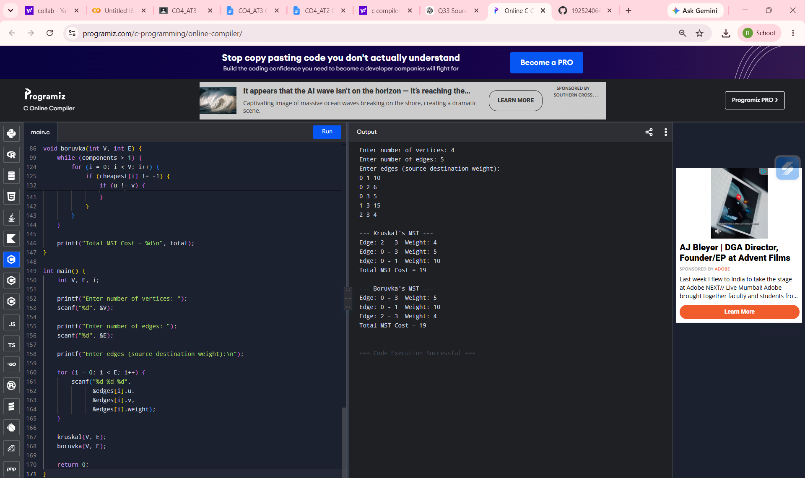
Figure 1: Successful execution of Kruskal’s and Borůvka’s MST program
WORKING / OBSERVATION
For the given graph, the edges are (0,1,10), (0,2,6), (0,3,5), (1,3,15), and (2,3,4). Kruskal’s algorithm sorts the edges by weight and considers them globally. It first selects the edge of weight 4, then weight 5, and finally weight 10. The resulting MST contains three edges and has a total cost of 19.
Borůvka’s algorithm identifies the cheapest outgoing edge for each current component. Because several components can select safe cheapest edges during the same phase, the order in which the edges are printed can differ from Kruskal’s order. Nevertheless, the resulting MST has the same minimum total cost of 19.
COMPARISON OF KRUSKAL AND BORŮVKA
Parameter | Kruskal’s Algorithm | Borůvka’s Algorithm
Basic strategy | Select globally lightest edges | Select cheapest outgoing edge of each component
Edge processing | Edges are processed in sorted order | Edges are scanned to find component-wise cheapest edges
Cycle handling | Uses Disjoint Set Union | Uses component merging / Disjoint Set Union
MST result | Minimum spanning tree | Minimum spanning tree
Typical complexity | O(E log E) with sorting | O(E log V) with efficient implementation
Best use | Simple and effective for many sparse graphs | Useful for component-based and parallel-style MST processing
Main limitation | Sorting all edges can add overhead | Repeated component/edge scans can be costly in some implementations
TIME COMPLEXITY
Kruskal’s Algorithm: O(E log E), mainly because the edges must be sorted. The DSU operations are near-constant amortized time with path compression and union by rank.
Borůvka’s Algorithm: O(E log V) with efficient component management. In each phase, the number of components decreases substantially, giving at most O(log V) phases.
SPACE COMPLEXITY
Both implementations require storage for the graph edges and component information. The auxiliary space is O(V), while storing the edge list requires O(E).
ADVANTAGES
Kruskal
- Simple and straightforward to implement.
- Works particularly well when the graph is represented as an edge list.
- DSU makes cycle detection efficient.
- Produces an MST with minimum total weight.
Borůvka
- Reduces the number of components rapidly in each phase.
- Naturally uses a component-wise greedy strategy.
- Can be adapted to parallel processing because cheapest edges can be found independently for components.
- Produces an MST with minimum total weight.
LIMITATIONS
- Kruskal requires sorting the complete edge list, which can be expensive for very large edge sets.
- Borůvka requires repeated scans of edges in a straightforward implementation.
- Both algorithms assume a connected graph if a single MST is required; a disconnected graph produces a minimum spanning forest.
- The practical performance depends on graph representation, implementation details, and graph density.
RESULT
Thus, the Minimum Spanning Tree of the given weighted graph was successfully constructed using both Kruskal’s and Borůvka’s algorithms. Both methods produced an MST with total cost 19. The experiment demonstrates that although the algorithms use different greedy edge-selection strategies, both can obtain an optimal MST when their respective conditions are satisfied.
CONCLUSION / INSIGHTS
Kruskal and Borůvka are greedy MST algorithms, but they make decisions at different levels. Kruskal chooses the globally smallest safe edge, while Borůvka chooses the cheapest safe outgoing edge for each component. Therefore, their intermediate edge-selection order may differ even though the final MST cost is the same. Kruskal is often convenient for edge-list representations, while Borůvka is attractive when component-wise processing and scalability or parallelization are important. The appropriate algorithm should be selected according to graph size, density, representation, and implementation requirements.

